INTERNSHIPS
Sl.No | Organisation | Job Role | Duration
1 | My Captain | Team Lead | 2020-2021
2 | Enfono Technologies | Sales intern | 2020-2021
3 | Tutoraj | Sales Head | 2021-2022

Sl.No | Organisation | Job Role | Duration
1 | Schlumberger(SLB) | ISS-1 | 2024-Present
2 | Schlumberger(SLB) | ISR | 2022-2024
3 | Jager Racing | Chief Engineer | 2018-2020
4 | ASME HPVC,Natuas | Brake Head | 2020-2021
5 | SAE,Efficycle, Black Mamba | Design Head | 2021-2022

Analytical & problem solving
Mechanical Production Engineer

ADDITIONAL COURSES
- Introduction to mechanical designing and analyses by coursera
- Micro machining and its parameter by NPTEL
- The finite element analysis for engineering physics by cousrera
- Capital budgeting and the demand forecasting by coursera
- Project management and it’s Risks by coursera
- SAP Sales module
- Introduction to design using solidworks by UDEMY
- Advanced Microsoft tools, PVA,PBI,PF
SKILL
Design & Analysis
Excel
3D Modeling
Microsoft PVA
Power Automate
SAP (SD)
Power Apps
Solidworks
Power BI
WORK EXPERIENCE
- SECONDARY SCHOOLING
St. George Senior Secondary School, Chengannur, Kerala, India
CGPA-10

- HIGHER SECONDARY
Maths Science.
SVGV HSS Kidangannoor, Arunmula, Kerala, India (2016-2018)
Pass Percentage – 98%

- UNDER GRADUATION
Bachelor of technology in mechanical and production engineering.
TKM College of Engineering, Kollam, Kerala, India (2018-2022)
CGPA – 9.57
EDUCATION
soorajletha205@gmail.com
8590689990

Kulangara veedu, Punthala (PO)
Venmoney, Chengannur, Alappuzha
Kerala, India 689509
An Independent and self motivated graduate with proven skills in SAP and Advanced Microsoft tools. Expert in using Microsoft tools like PBI, Power flow,PVA and always try to upskill myself by learning new things whenever i get a chance.
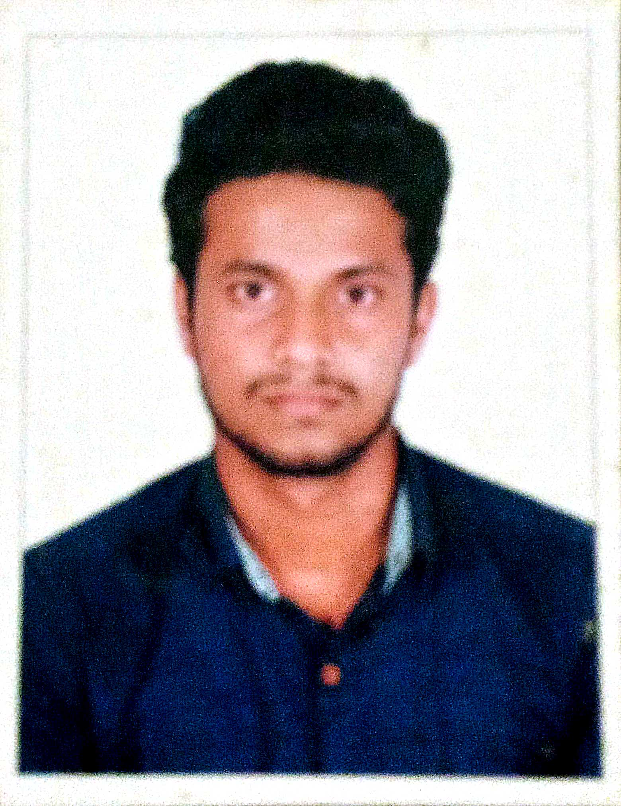
Sooraj Santhosh
Sl.No | Project Title | Project Guide | Institution
1 | Automatic height adjusting mic stand | Prof. Shiffin A S | TKM College of engineering
2 | Design and fabrication of hybrid solar still | Dr. Biju V. | Energy research lab, TKMCE
3 | Performance investigation of adsorbtion desalination system | Dr. Baiju V | Energy research lab, TKMCE
4 | Integration of hybrid solar still with adsorption desalination unit | Dr. Baiju V. | Energy research lab, TKMCE
5 | Design, analysis and fabrication of electric kart | Dr. Ahmed Vasim | Electrical vehicle society, TKMCE
6 | Design, analysis and fabrication of human powered vehicle | Dr. Riji Jacob Thomas | ASME, TKMCE
7 | Design , analysis and fabrication of hybrid three wheel vehicle | Dr. Ahmed Vasim | SAE, TKMCE
Sl.No | Languages | Read | Write | Speak
1 | English | yes | yes | yes
2 | Malayalam | yes | yes | yes
3 | Tamil | no | no | yes
4 | Hindi | yes | yes | yes
INTERESTS
LANGUAGES
PROJECTS

Music
Travelling
Driving
Outdoor Games
Cooking
Teaching

Films
Sports

ORGANISATIONS
- NCC best cadet of CATC Pathanapuram , 2017
- NSS State level magazine editorial board member
- NCC certificate passed
- All India rank 2nd in national electric kart championship, 2020
- Best intern of Tutoraj, June 2020
- Best intern of enfono technologies , December 2020
- Best out going student, of St.George senior secondary school, 2016
- Best out going student, of SVGV HSS, 2018
- Topper in KTU university exams in first appearance
- SAP Super User
- Sales Intern at Tutoraj , May 2020- July 2020
- Intern at Enfono technologies , November 2020- January 2021
- Reema group, May 2021- December 2021
- Jager Racing, November 2018- April 2019

INTERNSHIPS
IEDC
ISTE
NCC
NSS
ASME
ACHIEVEMENTS
ISIE
IE
SAE

